1.Product Details
golf grips for golf putter club
Material | Silicone and EVA core
Brand | OEM/Customer's design is welcomed
Color | Orange and green
Size | Middle size
Weight | 50g
Length | 263mm
Cap Size: | Same with super stroke 3.0
Logo | Embossed logo on golf grip cap and body
Feature | Could be used a long time without slippery  The pattern could changed as your request  good tackiness and fantastic control.  Competitive unit price with timely delivery.
Package | Inner Package: Individual PE plastic sheet
 | Outer Package: 250pc/carton, neutral export standard carton(welcome custom made)
Lead Time | Sample: 2-3 weeks with logo
 | Order: 4-5 weeks after order confirmed

2.Pictures: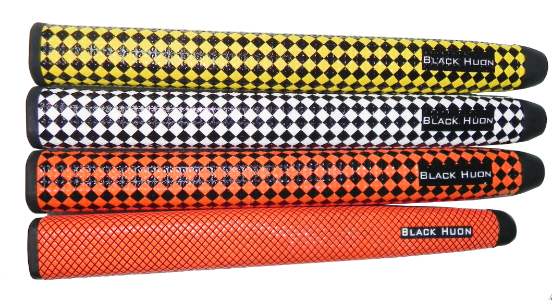

3.Company information
1998---A family business, a golf bag workshop, was founded, focusing on the local Chinese market.
2005---Moved to new 5000 square meter factory, employing 200 workers, with a production capability,
to produce 5000pcs per month.
2006---TH-SPORT (H.K.) was established, started to export our products world wide.
2008---Became partners with Grip, Glove, Cap & Umbrella factories.
2009---Started doing business with, Maxfli, Mercedes-Benz, Jaguar, Cleveland,Tommy Armour, Dunlop,
Hippo, Hello Kitty,Yamamoto, Ecco and a range of smaller companies.
2010---Opened a show room, to display all we have, on the pretty Xiamen Island, as a central convienent
location for our customers.
2016---We are focusing on developing high quality, innovative & fashionable golf products

4. Our Service
OUR ADVANTAGE:
1)We produce a range of High quality & fashionable products : We are consistently adding to our range, of
innovative & fashionable items. Having the highest quality is our first prority.
2) We are a Professional Manufacturer: we have been golf products manufacturer since 1998, we have a
wealth of experience.
3) Factory Price: You WILL benifit by our competitive pricing.
4)On time delivery: Being in manufacturing for more than 15 years, we have a wealth of experience, to control &
ensure, on time shipping .
5) Quality guarantee: Every order, we will offer a Pre production sample for quality confirmation before main production

5. FAQ
1.What is your main products?
Our main products are golf bag, headcover, club set, grip and other golf accessories, we offer OEM services.
2.What is your MOQ?
Our MOQ is usually 500 pcs
3.What is your time of making samples?
Usually we will take 2-3weeks to make the samples.

6. Contact
Company: Xiamen TH-SPORT CO. LTD
Atten: Katie Zhong
Skype: thsport18
Whatsapp/Wechat: 0086 150 5912 8499
Email: sales01@th-sport.com
Web: www.tt-golf.com
Add: Floor 5th, Second elevator, Industrial Building, No. Fang Hu Road, Hu Li, Xiamen, 361006, China
